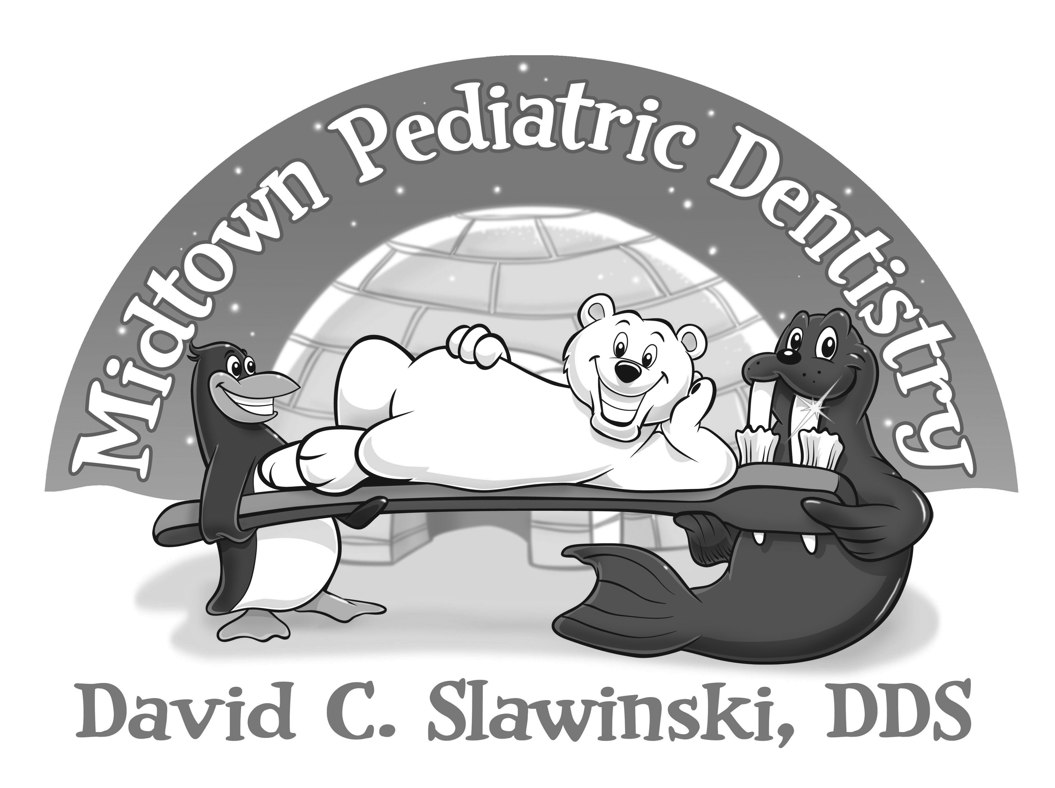

Child’s Demographic Information
First Name ________________________ Middle Initial ______ Last Name __________________________________
Preferred Name ________________ Age ______ Date of Birth ____/____/_______ Sex M F
Home Address _______________________________________ City ____________________ State ______ Zip _____________
Names/ages of siblings _________________________________ _____________________________________________
What is the reason for today’s visit? ____________________________________________
Whom may we thank for referring you to us? ________________________________________________
Parent Demographic Information
Mother’s Name ____________________________________ Mother’s Date of Birth ___/___/______
Home Phone ____________________ Cell Phone ______________________ Work Phone ______________________
Email _______________________________________________ Employer ______________________________________
Father’s Name ____________________________________ Father’s Date of Birth ___/___/______
Home Phone________________________ Cell phone _____________________ Work Phone ____________________
Email ________________________________________________ Employer ______________________________________
Person responsible for payment of account ______________________ SS# _____________________
Child lives with: Both parents Mother Father Other____________________ Who has legal custody? __________________
Health History
Child’s Physician _______________________________________________ Date of last exam ___/___/______
Yes No Is your child in good health?
Yes No Has your child ever had a health problem? ____________________________________________
Yes No Has your child ever been hospitalized? Please give reason and dates: ______________________
______________________________________________________________________________
Yes No Is your child allergic to anything? _________________________ Latex Allergy Yes No
Yes No Is your child currently taking any medications? Please give medication, dose and reason:
______________________________________________________________________________
Yes No Were there any problems at birth? __________________________________________________
Please circle if your child has been treated for any of the following:
Heart disease Bleeding/transfusions Asthma/breathing Blood dyscrasias
Liver/GI disease Anemia Diabetes Adverse drug reactions
Kidney disease Rheumatic fever Hepatitis Mental delays
Speech/hearing Seizures Cleft lip/palate Physical delays
Eyesight Congenital birth defects Personality/social Cancer/tumors
Please Elaborate on any items circled : ___________________________________________________ __________________________________________________________________________
- Please continue to the back -

Dental History
Yes No Has your child ever been to the dentist?
Name of dentist and date: _________________________________________________________
Yes No Has your child experienced any unfavorable reaction from previous dental care? ____________
Please explain __________________________________________________________________
Yes No Does your child suck a finger, thumb, or pacifier? ______________________________________
Yes No Does your child have pain with chewing, yawning, or wide opening? ______________________

Please check if your child is having problems with any of the following:
Cavities Toothache Sensitive teeth
Trauma Gum infections Color of teeth
Orthodontics Jaw sounds Other

Comments/Concerns: ______________________________________________________________________________
________________________________________________________________________________________________

Fluoride History
Yes No Is your home water supply fluoridated?
Yes No Does your child use a fluoride toothpaste?
Yes No Do you give your child any other form of fluoride? What? _______________________________

Consent for Dental Treatment

I request and authorize Dr. Slawinski to examine, clean, and provide dental treatment on my child’s teeth. I further request and authorize the taking of dental x-rays as may be considered necessary by Dr. Slawinski to diagnose and/or treat my child’s dental problem. I will allow photographs to be taken of my child or child’s teeth for diagnostic or educational purposes. I understand that dental treatment for children includes efforts to guide their behavior by helping them to understand the treatment in terms appropriate for their age. Dr. Slawinski will provide an environment likely to help children learn to cooperate during treatment by using praise, explanation and demonstration of procedures and instruments.

Signature ___________________________________________ Date ___________________________

